Data Structures (ETCCDS202)
Unit–1 Assignment: Foundations & Algorithmic Analysis
Course Details
Name of the School:SOET (School of Engineering & Technology )
Program : CSE Robotics and AI
Semester :2
Batch:2025-2029
Student Name:Ajitesh Singh Gusain
Task 6 (Recursion Implementation + Trace + Complexity (Coding C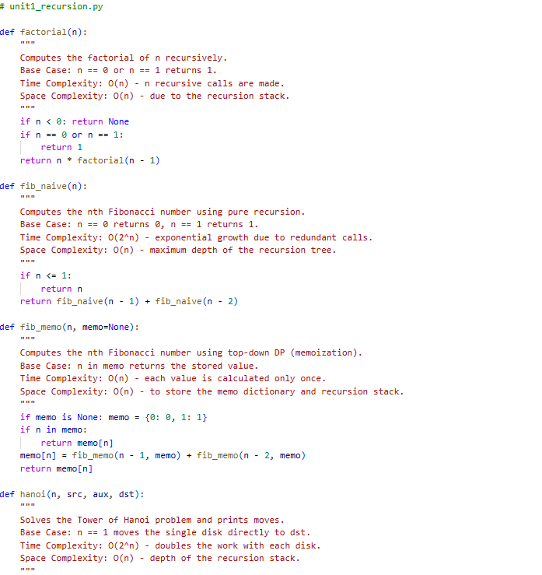

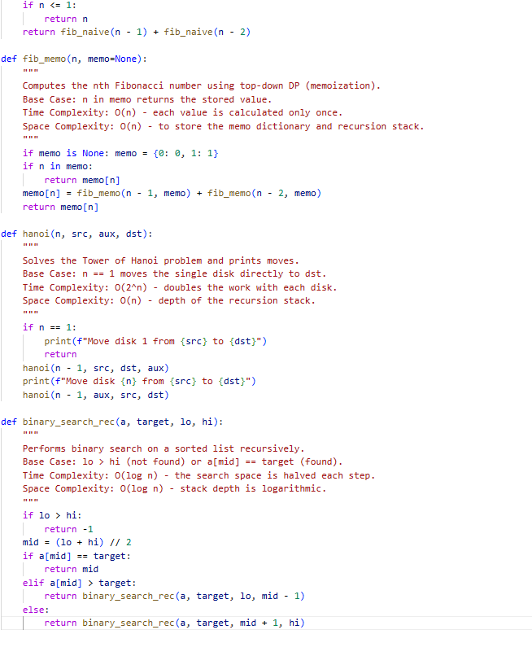

6.1. Recursive Factorial Trace (n=5)
To trace the call stack, we show the downward sequence of calls (winding) and the upward sequence of returns (unwinding).
The sequence of calls:
- factorial(5) calls factorial(4)
- factorial(4) calls factorial(3)
- factorial(3) calls factorial(2)
- factorial(2) calls factorial(1)
- factorial(1) calls factorial(0)
The sequence of returns:
- factorial(0) returns 1 (Base Case)
- factorial(1) returns 1 \times 1 =1
- factorial(2) returns 2 \times 1 =2
- factorial(3) returns 3 \times 2 =6
- factorial(4) returns 4 \times 6 =24
- factorial(5) returns 5 \times 24 =120

6.2. Fibonacci: Naive vs. Memoization
Why Naive Fibonacci is slow:
The naive recursive implementation has a time complexity of approximately O(2^n). This is because it performs a massive amount of redundant calculations. For example, to calculate fib(5), the function calculates fib(3) twice and fib(2) three times. As n increases, the number of duplicate calls grows exponentially, forming a massive recursion tree.
How Memoization fixes it:
Memoization introduces a lookup table (usually a dictionary or array). Before performing a recursive call, the function checks if the result for that n is already in the table.
- If yes, it returns the stored value immediately (O(1)).
- If no, it calculates it once and stores it.
This transforms the recursion tree into a linear path of n unique calls, reducing the time complexity to O(n).

6.3. Tower of Hanoi (n=3)
Move Sequence (Source: A, Aux: B, Destination: C):
- Move disk 1 from A to C
- Move disk 2 from A to B
- Move disk 1 from C to B
- Move disk 3 from A to C
- Move disk 1 from B to A
- Move disk 2 from B to C
- Move disk 1 from A to C
Complexity Analysis:
- Total number of moves formula: 2^n - 1
- Time Complexity: O(2^n) — Since every disk move must be printed and the number of moves doubles with each additional disk.

6.4. Recursive Binary Search Analysis
The Recurrence Relation:
The time complexity T(n)can be expressed as:
T(n) = T(n/2) + O(1)
Justification of O(\log n):
- Divide and Conquer: In each step, the algorithm compares the target to the middle element.
- Reduction: Because the list is sorted, we can discard exactly half of the remaining elements every time.
- Depth: We are essentially asking: "How many times can we divide n by 2 before we reach 1?" The answer to that is mathematically defined as \log_2 n.
- Conclusion: Since we perform a constant amount of work (O(1)) at each level of the recursion and there are \log n levels, the total time complexity is O(\log n).

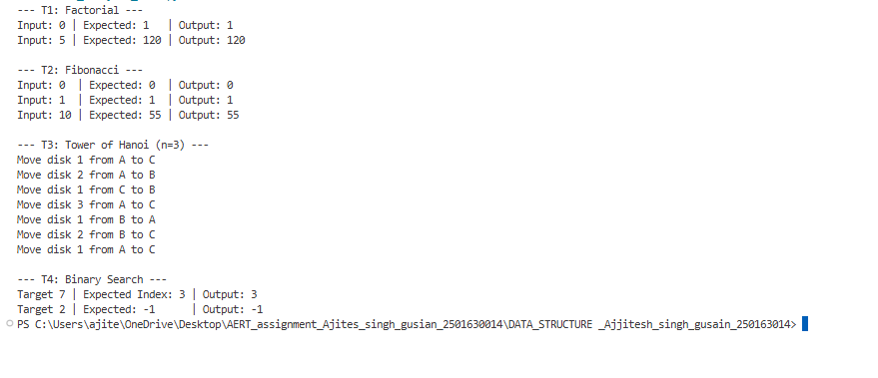

Bonus Task
Observation on Fibonacci Performance: When calculating the 35th Fibonacci number, the difference between naive recursion and memoization is staggering. The naive approach takes several seconds because it recalculates the same sub-problems (like fib(2)) millions of times in an exponential O(2^n) pattern. In contrast, memoization finishes almost instantly (under 0.0001 seconds) because it stores the result of each sub-problem the first time it is solved. This reduces the work to a linear O(n) complexity, demonstrating how dynamic programming effectively trades a small amount of memory for a massive gain in speed.

